ACCOMPLISHMENT REPORT
IT 205 & 205L – Object-Oriented Programming
Month: August & September – Year: 2025
School Year: 2025 – 2026 1st Semester

DATE | ACCOMPLISHMENT | REMARKS  (Progress and deviations from the plan) *
August 18 – 22, 2025 | Orientation  - SLSU Vision, Mission, Goals, Objectives and Quality Policy  - Program Outcomes  - Course Outcomes  - Course Outline  - Course Requirements  - Gender Awareness and Development (GAD)  - Course Grading System  - Student/s with Special Needs  - Disaster and Risk Preparedness  Lecture Accomplishments:  - Explained the fundamental concepts of Object-Oriented Programming (OOP), including classes, objects, encapsulation, abstraction, and inheritance, to build a foundational understanding.  - Discussed the advantages of OOP compared to procedural programming by analyzing efficiency, modularity, and code reuse.  - Explained the structure and execution of a JavaScript program, emphasizing how the runtime environment processes scripts.  Laboratory Accomplishments:  - Identified and used the JavaScript environment by executing basic programs in both the browser console and Node.js terminal.  - Wrote and executed a simple JavaScript program to display text outputs, ensuring correct syntax and logical flow.  - Applied single-line and multi-line comments in JavaScript code to improve documentation and readability during coding exercises. | Accomplished,  Accomplished,  Accomplished
August 25 – 29, 2025 | Lecture Accomplishments:  - Identified the use of the JavaScript environment (browser and Node.js) and compared their functions in executing scripts.  - Analyzed the role of the ‘this’ keyword in JavaScript, explaining how it refers to the current object in different contexts.  - Discussed examples showing how ‘this’ operates within methods and constructors to demonstrate object behavior.  Laboratory Accomplishments:  - Displayed outputs using console.log() in JavaScript and differentiated it from Java’s System.out.println() for clarity.  - Implemented a basic program that combined outputs and comments, reinforcing code readability and debugging skills.  - Tested JavaScript scripts in both browser and Node.js, observing differences in execution results. | Accomplished,  Accomplished
September 1 – 12, 2025 | Lecture Accomplishments:  - Explained the structure and execution of a JavaScript program, showing how code runs in sequential order.  - Analyzed the differences in runtime behavior between browser and Node.js environments.  - Demonstrated practical examples where the ‘this’ keyword is applied in defining object behaviors and constructors.  - Evaluated the advantages of using OOP over procedural programming by highlighting modularity, reusability, and scalability.  - Applied the concept of encapsulation in sample code snippets to show how data hiding is achieved.  Laboratory Accomplishments:  - Wrote and executed a basic JavaScript program that displayed messages to validate proper syntax and structure.  - Conducted hands-on coding to compare console.log() in JavaScript with System.out.println() in Java, identifying similarities and differences.  - Applied single-line and multi-line comments to document code, emphasizing clarity in program documentation.  - Implemented simple object-based programs where the ‘this’ keyword was tested within methods and constructors.  - Reflected on how the ‘this’ keyword behaves differently in the global scope, function calls, and constructor usage by running small code experiments. | Accomplished,  Accomplished
September 15 – 19, 2025 | Lecture Accomplishments:  - Explained the role of the ‘this’ keyword in different JavaScript contexts, including methods, constructors, and global scope.  - Differentiated how procedural programming handles program flow compared to OOP and event-driven structures.  - Applied abstraction by presenting simplified class models to hide unnecessary details while focusing on key behaviors.  Laboratory Accomplishments:  - Conducted coding tasks where students created JavaScript objects and verified how the ‘this’ keyword binds within methods.  - Implemented a small constructor function to practice object instantiation and use of the ‘this’ keyword.  - Tested variations of the ‘this’ keyword inside event handlers and compared outcomes with regular function calls. | Accomplished,  Accomplished
September 22 – 26, 2025 | Lecture Accomplishments:  - Explained how encapsulation in JavaScript classes secures data and controls object interactions.  - Analyzed the benefits of inheritance in reducing code duplication and improving modular design.  - Applied real-world examples to illustrate abstraction, showing how simplified models represent complex systems.  - Demonstrated sample programs combining inheritance and the ‘this’ keyword to highlight reusability and object reference.  Laboratory Accomplishments:  - Conducted programming tasks where students wrote JavaScript classes with encapsulated properties and methods.  - Implemented class inheritance in JavaScript to extend functionality between parent and child classes.  - Tested multiple class objects to observe how the ‘this’ keyword behaves in extended methods.  - Reflected on how encapsulation and inheritance support scalability in larger program designs. | Accomplished, Accomplished
September 29 – 30, 2025 | Lecture Accomplishments:  - Implemented sample programs demonstrating the combined use of encapsulation, abstraction, and inheritance in JavaScript.  - Evaluated the role of the ‘this’ keyword in advanced object interactions to conclude Module 1 coverage.  Laboratory Accomplishments:  - Reflected on the overall strengths and limitations of OOP concepts when applied in JavaScript projects. | Accomplished,  Accomplished
*Provide relevant documentation such as pictures, summary reports, etc.

Prepared by: Approved:

JUNNIE RYH M. SUMACOT SHERWIN G. CADAY, PhD.
Instructor Program Chair

ROOF/EVIDENCE OF REPORTED ACCOMPLISHMENTS
IT 205 & 205L – Object-Oriented Programming
Month: August & September – Year: 2025
School Year: 2025 – 2026 1st Semester

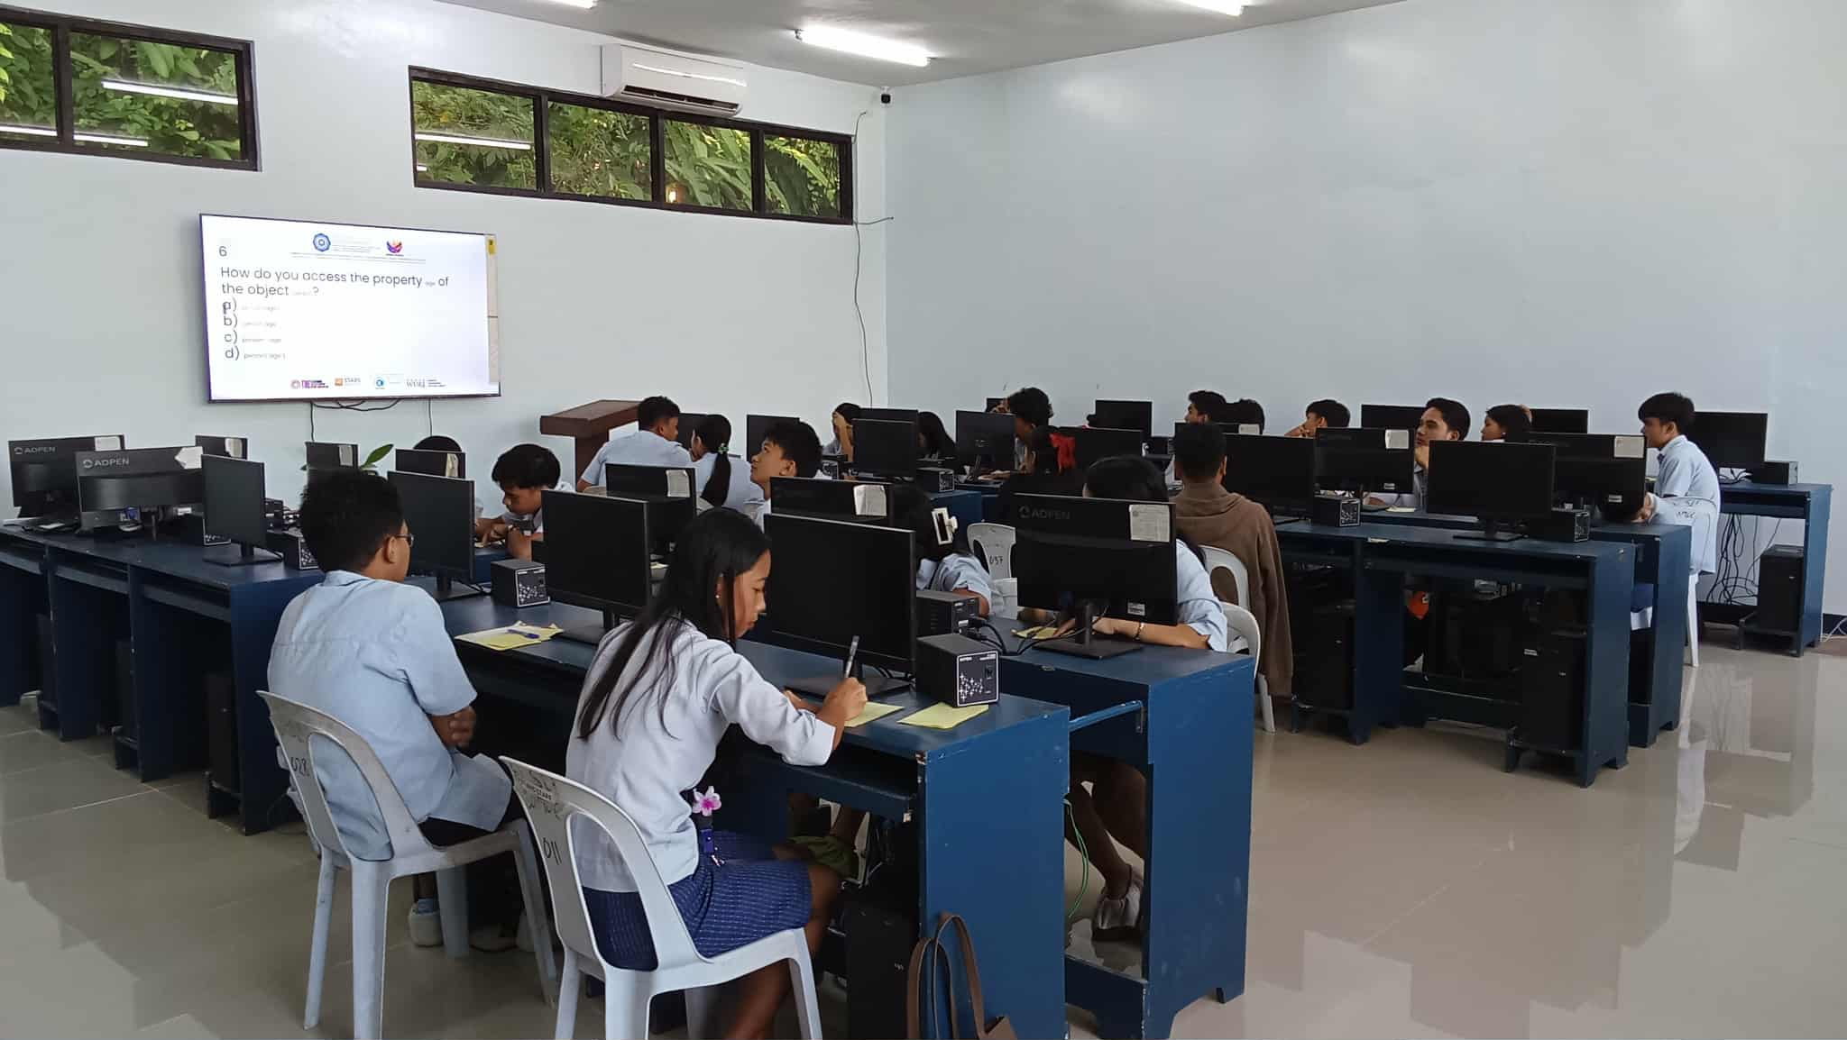


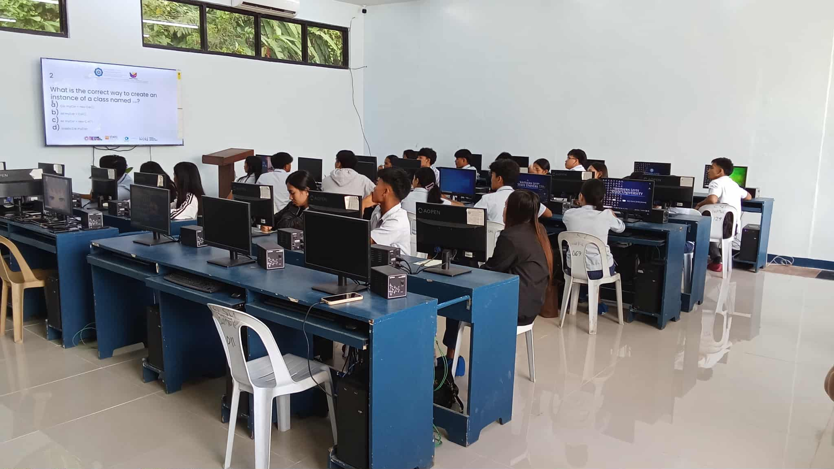
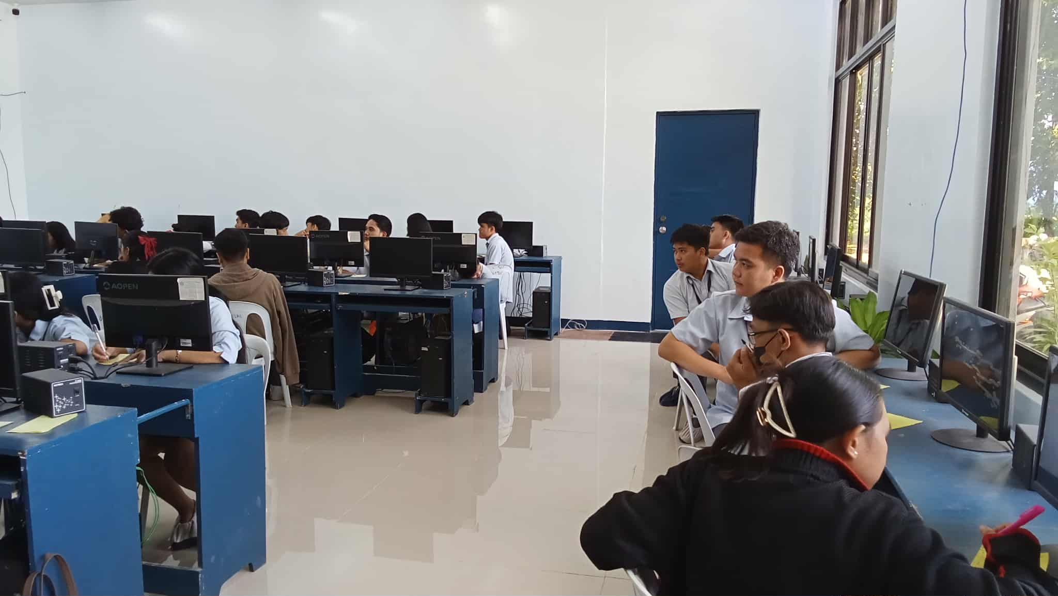


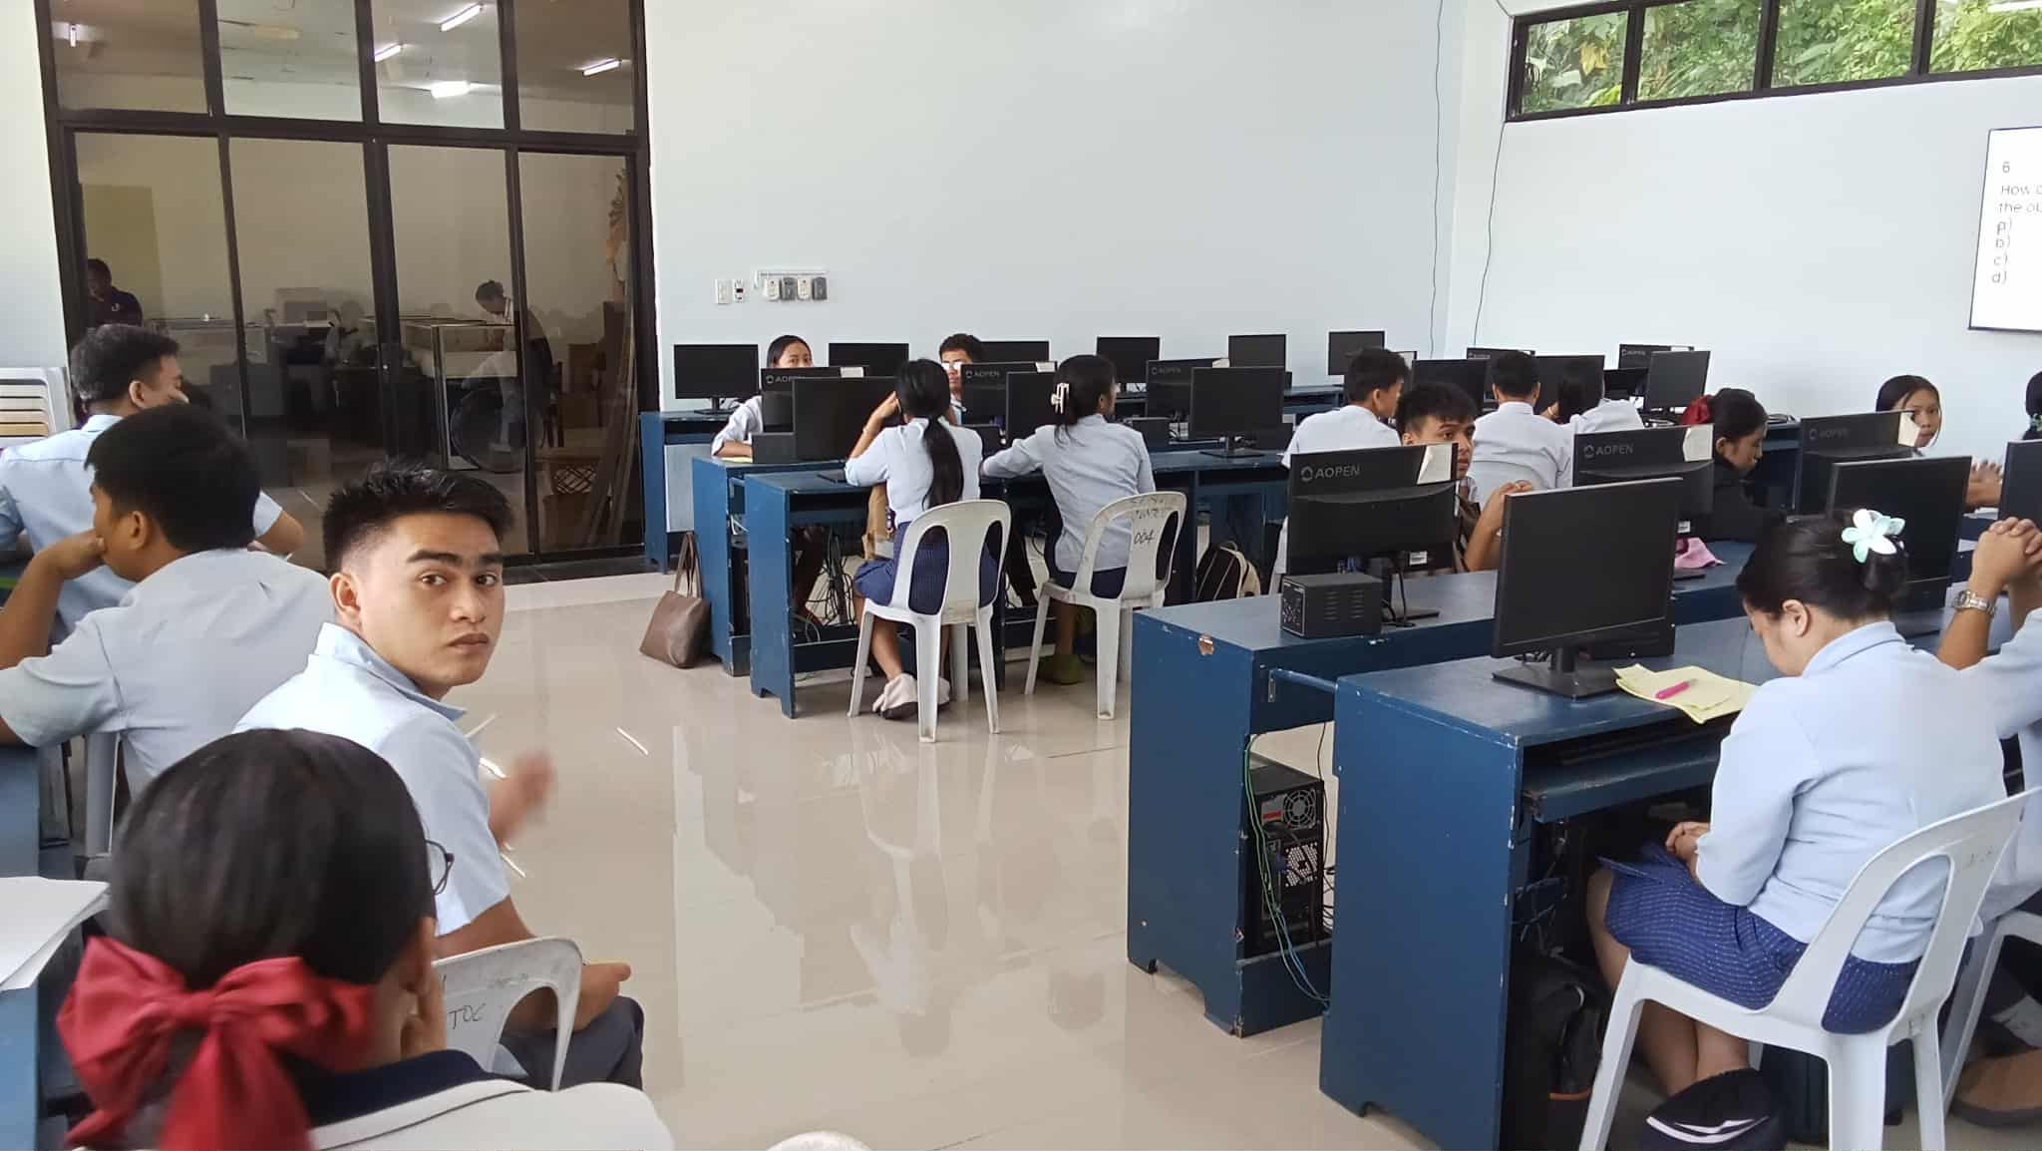

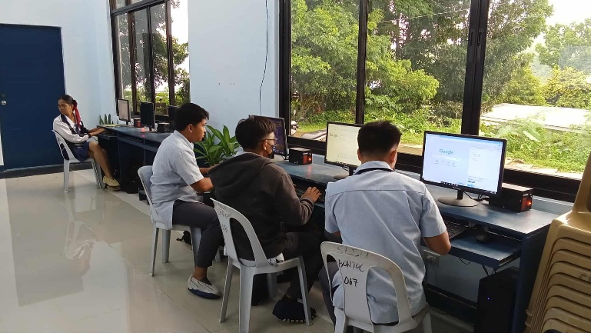
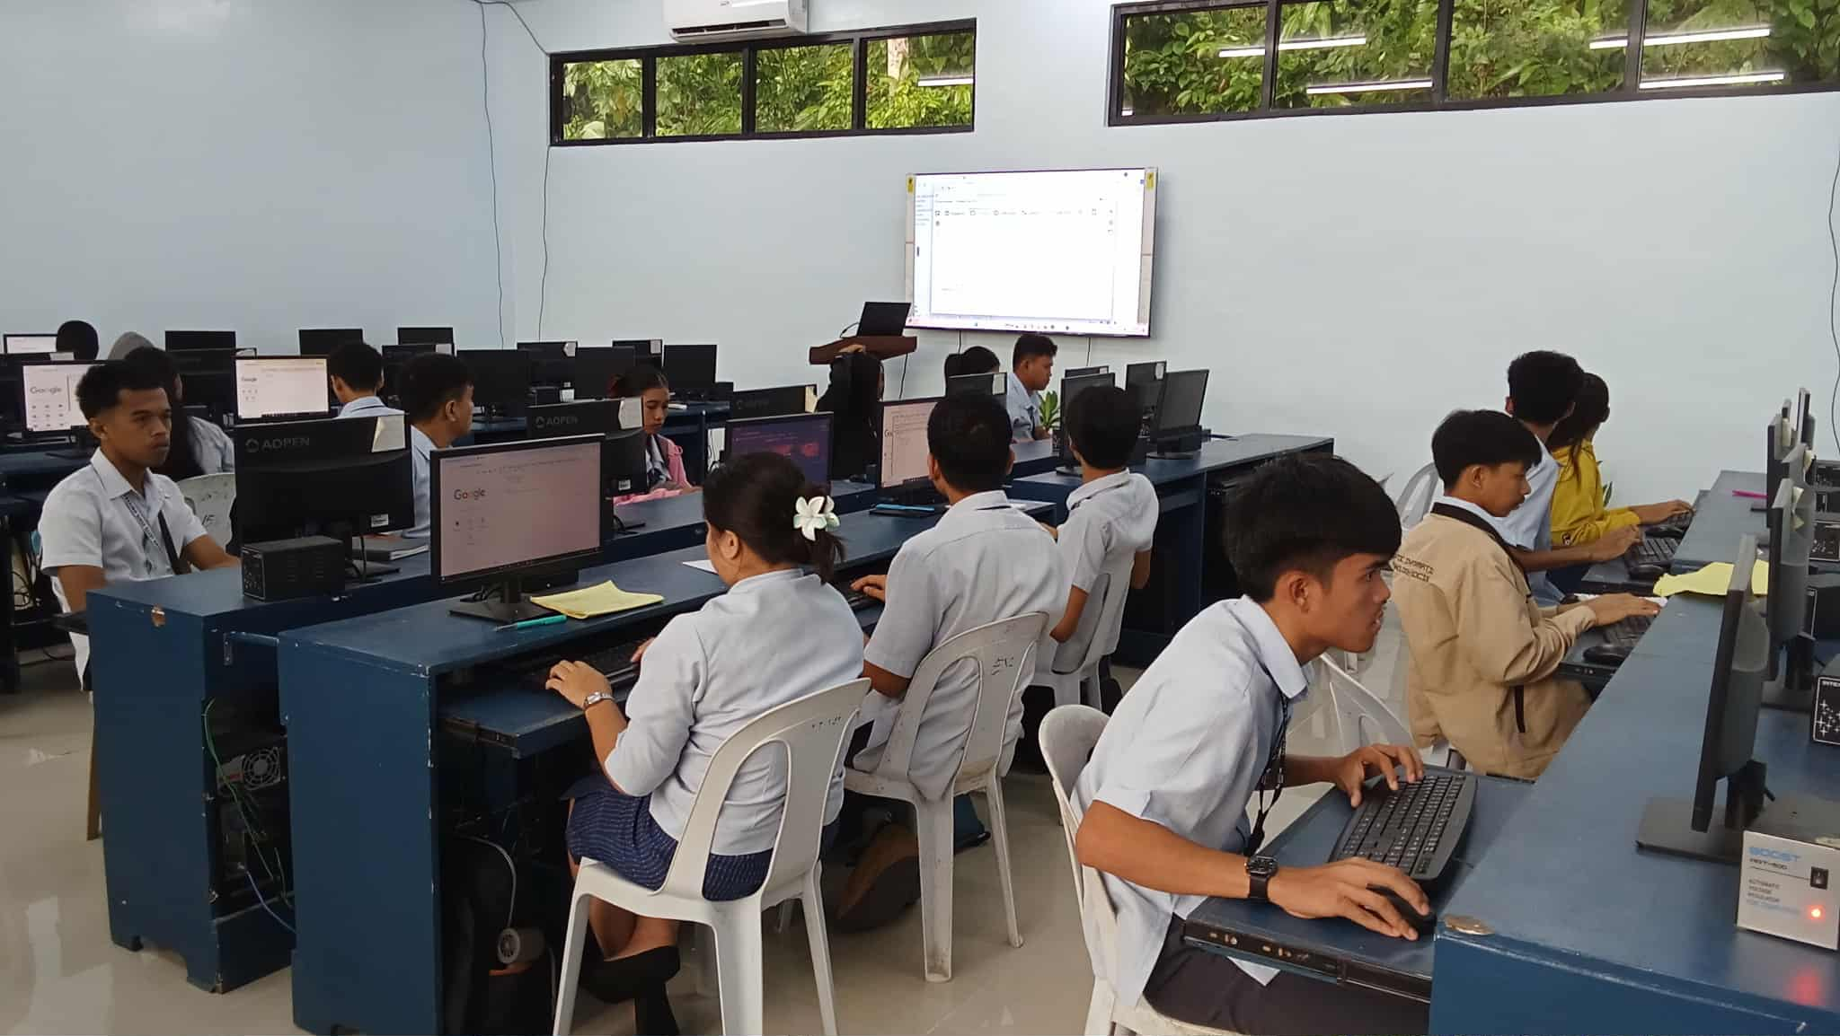

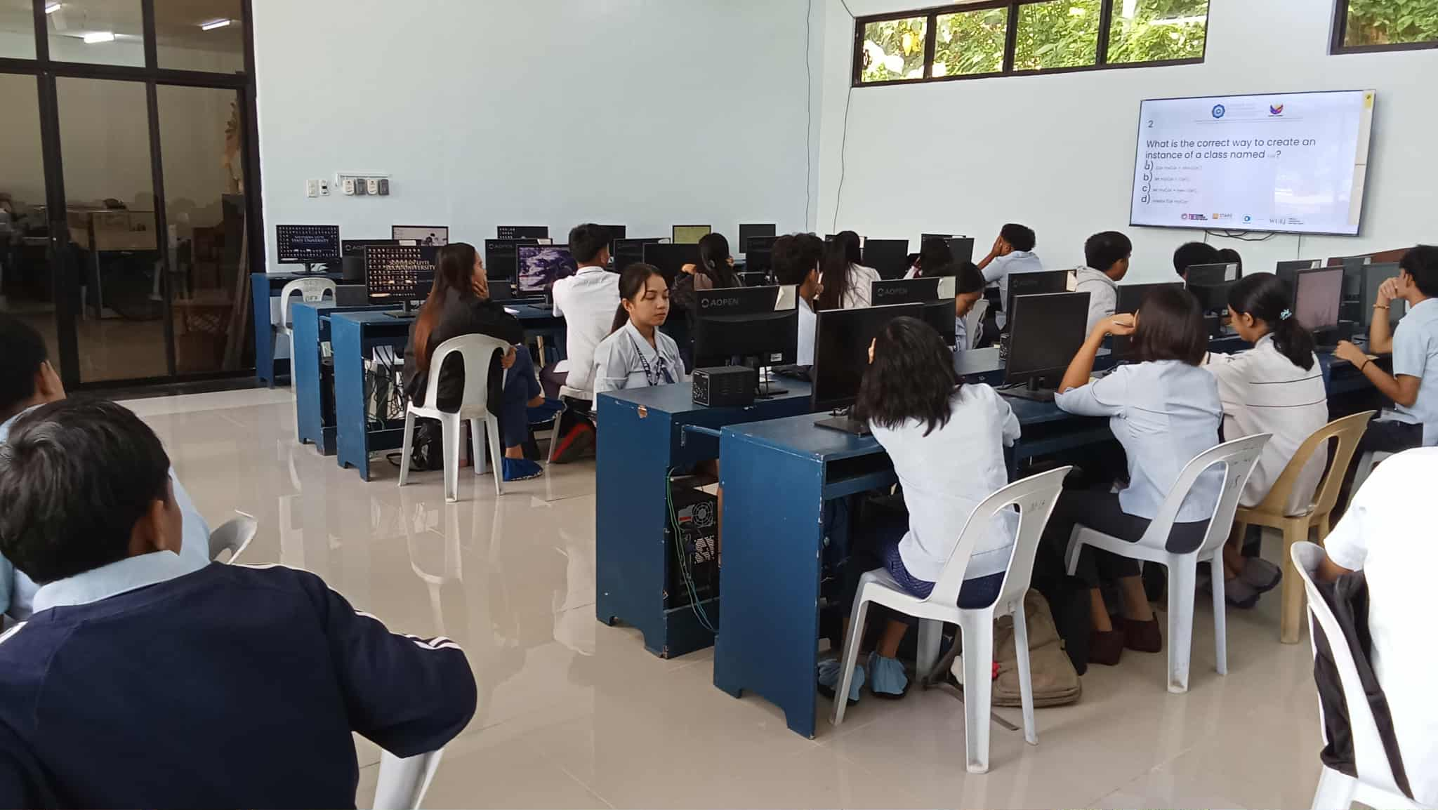





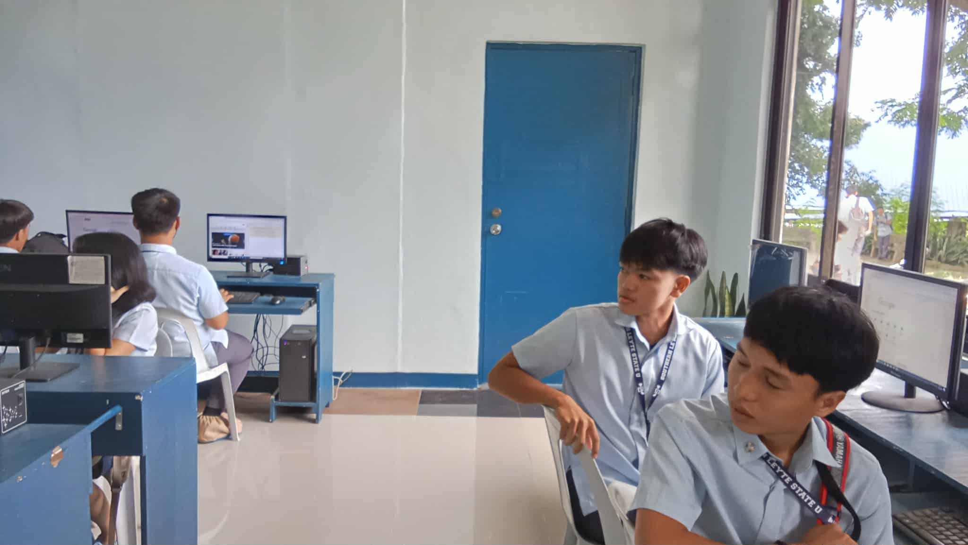


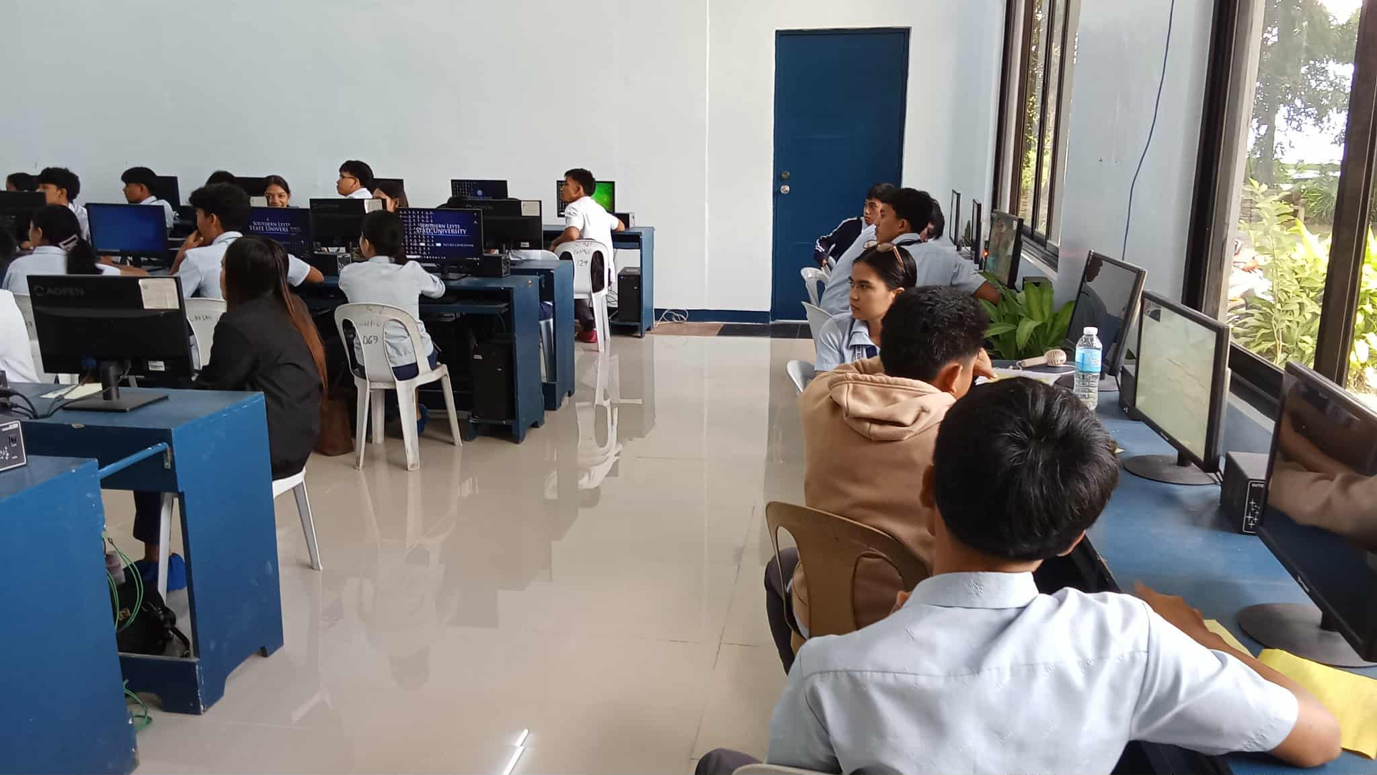



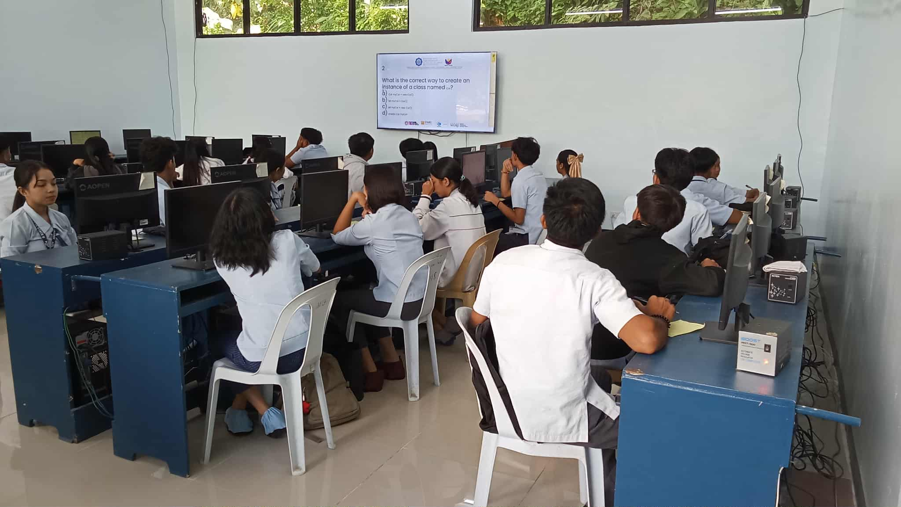




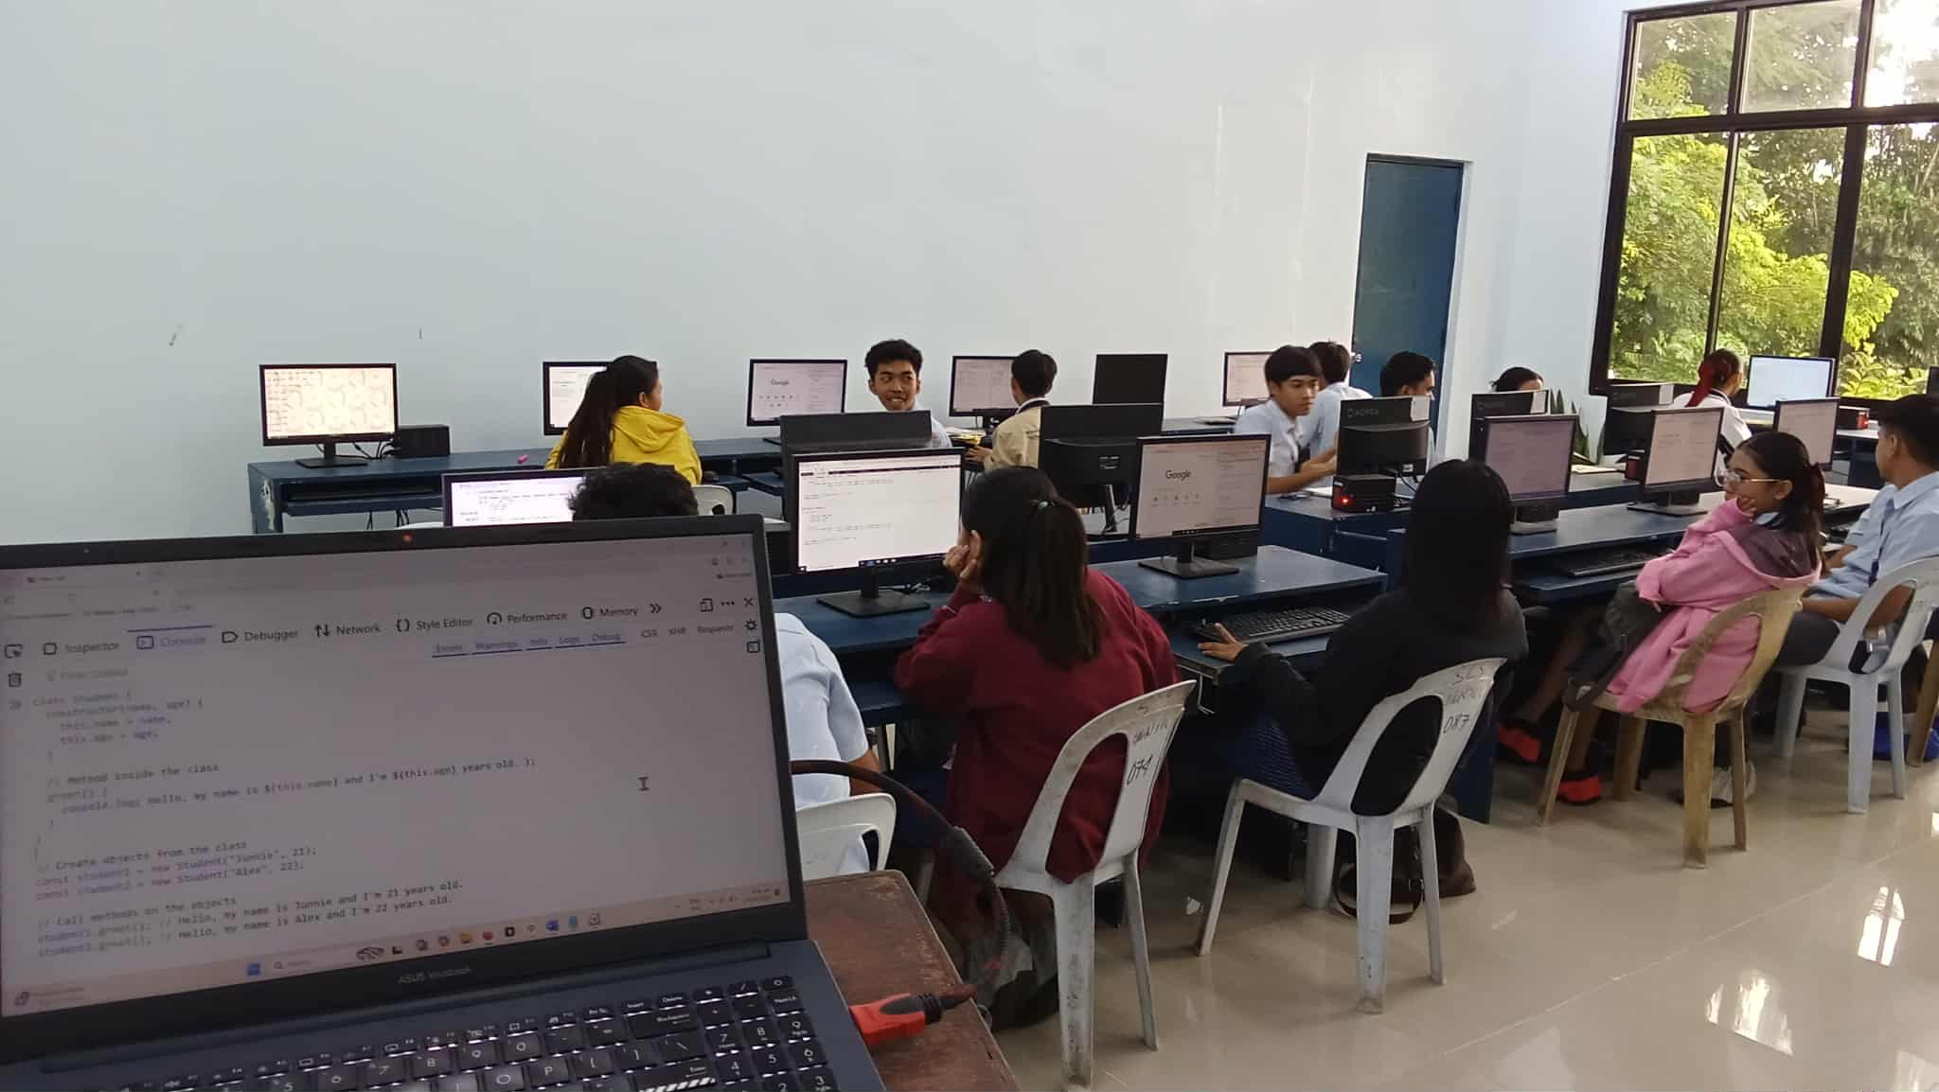
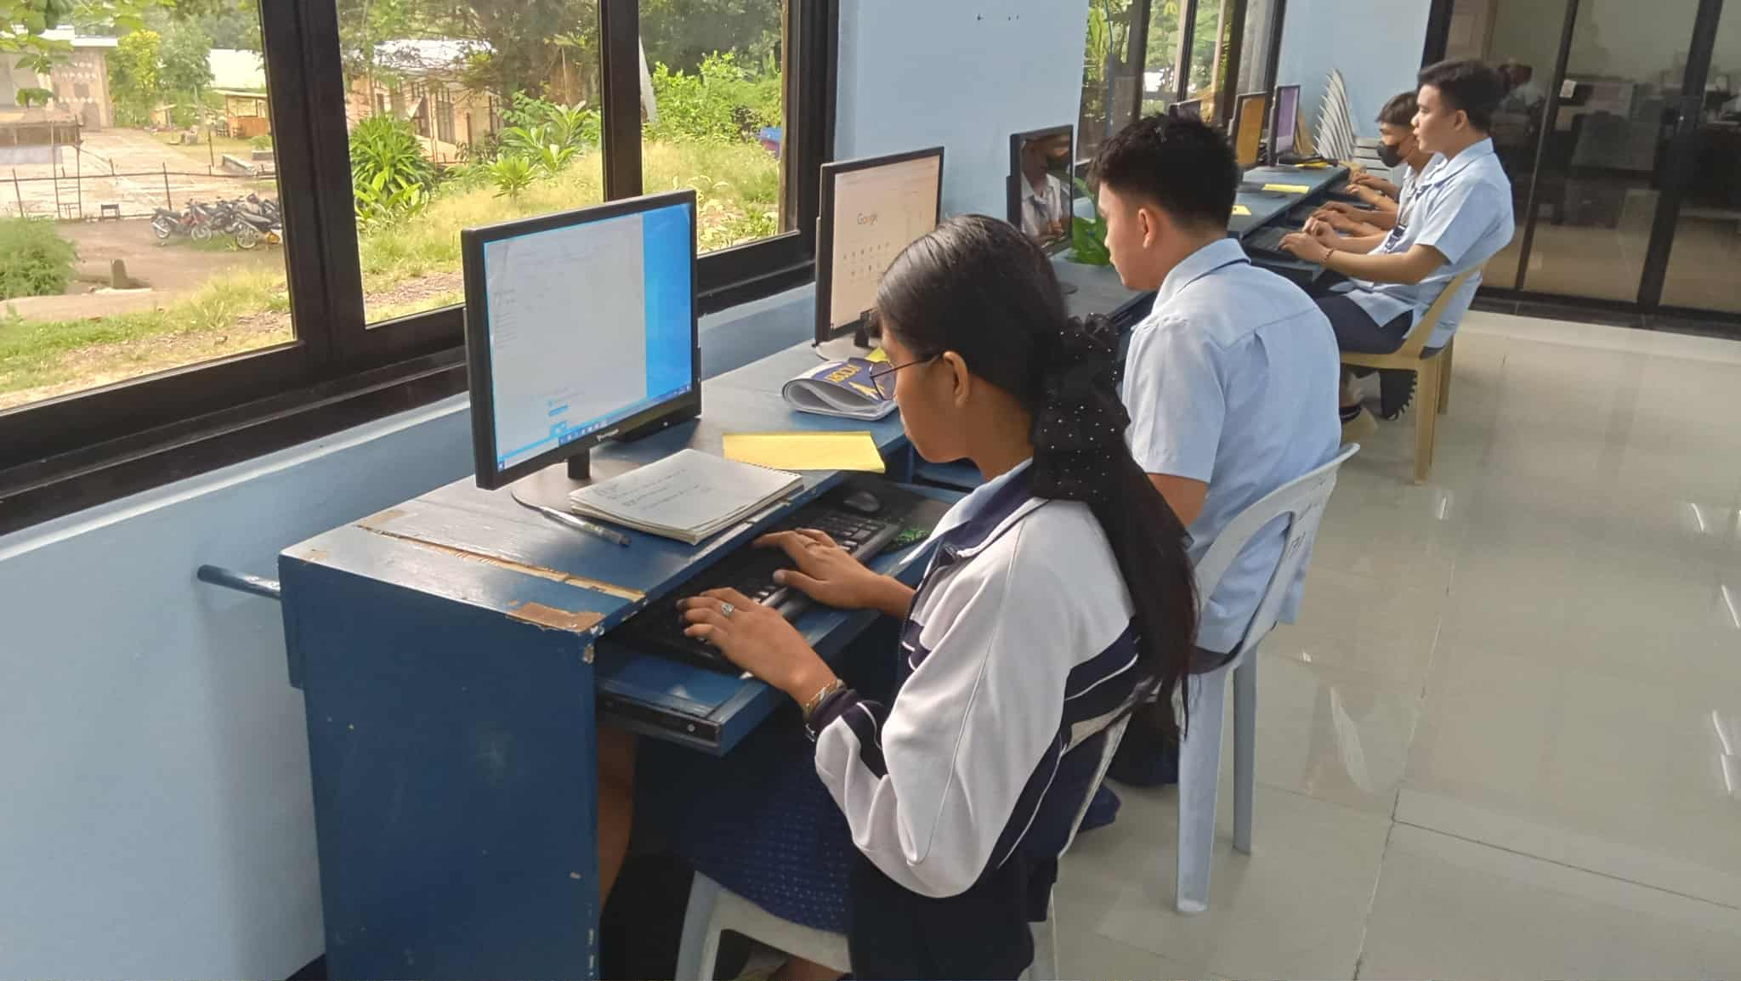

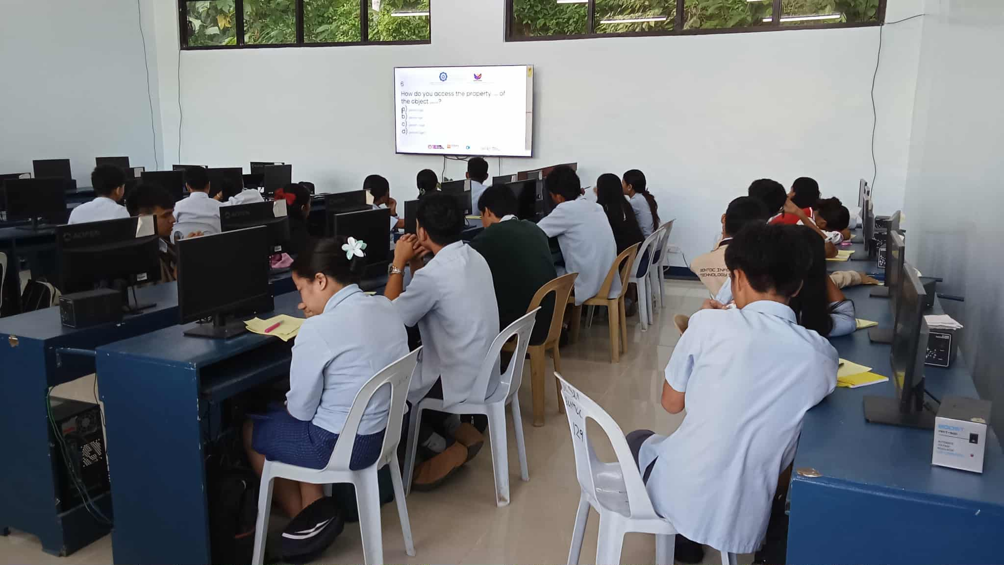
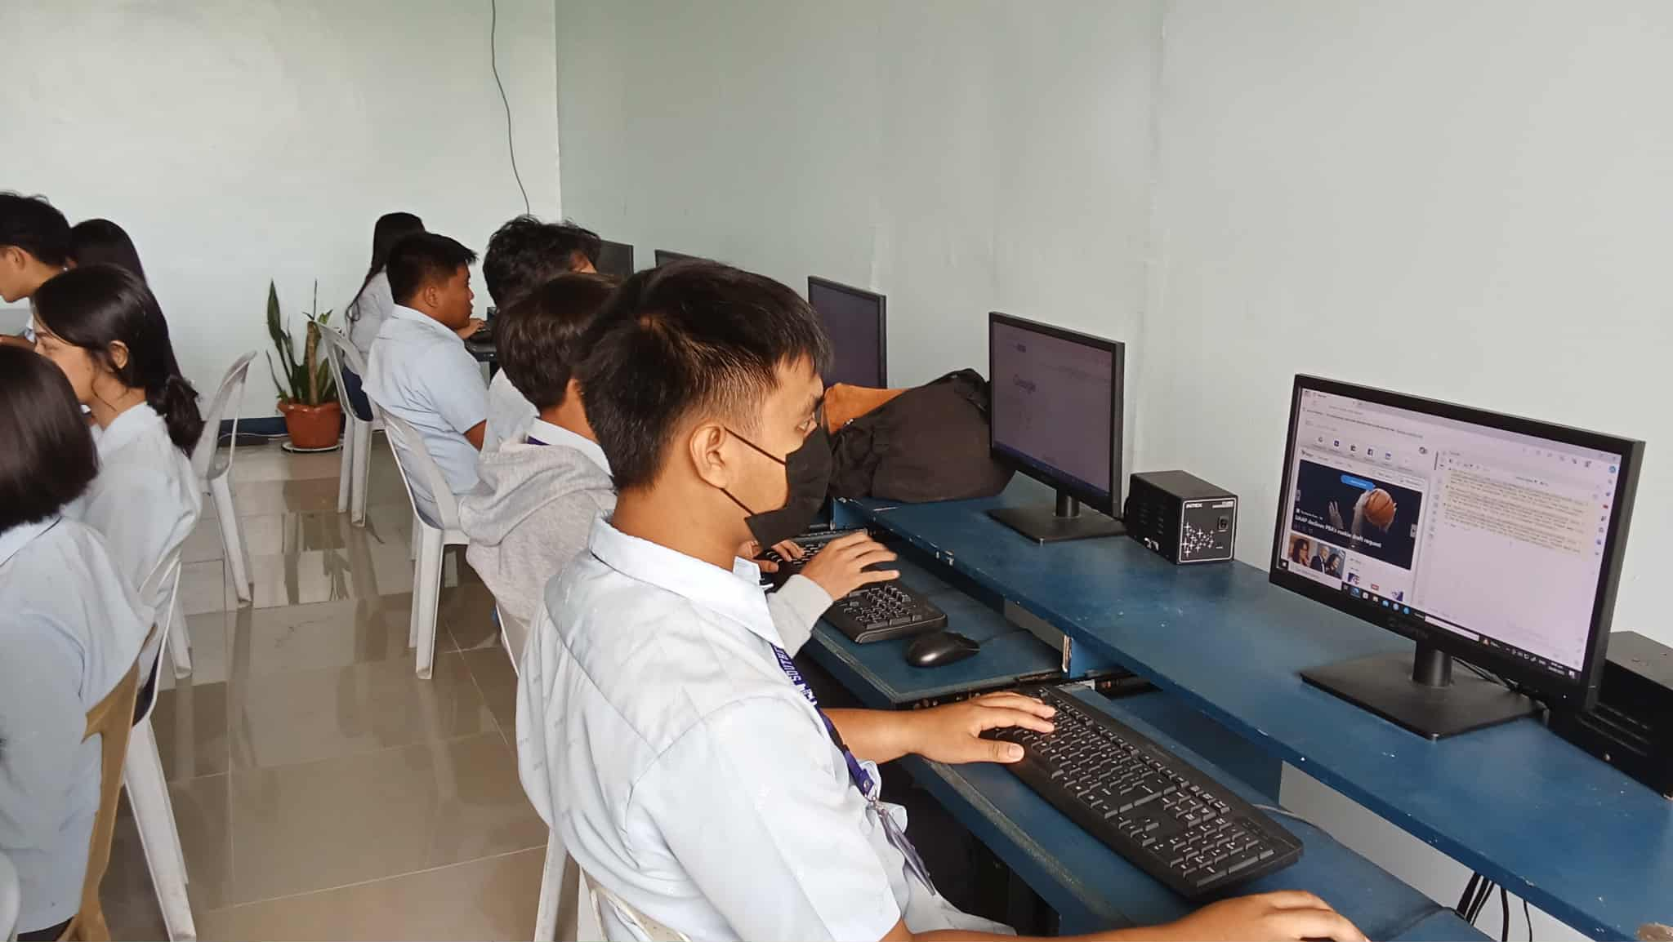

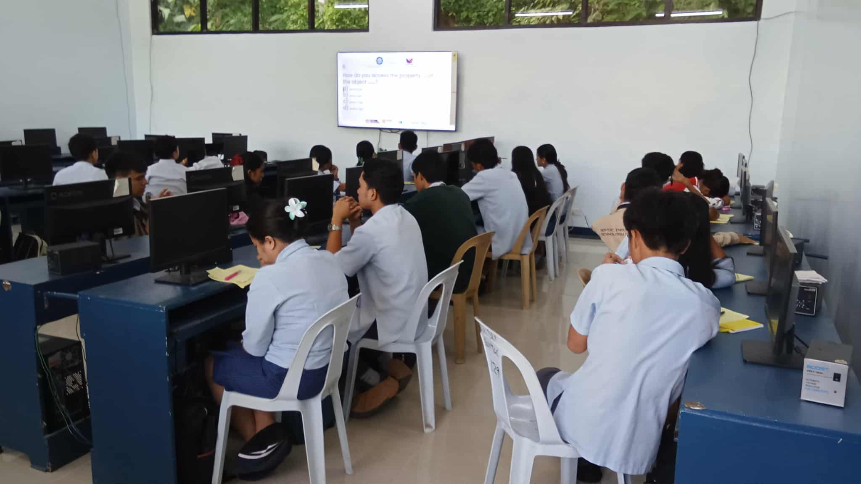


Prepared by: Approved:

JUNNIE RYH M. SUMACOT SHERWIN G. CADAY, PhD.
Instructor Program Chair

